Form Guide
1 | St Ives (SW) | W | W | W | W | W | W | W | W | 100%
11 | Crediton | L | D | D | W | L | D | W | L | 22.5%
Tribute Cornwall & Devon RFU League Table
# | Team | Pd | W | D | L | F | A | Diff | 4T | LB | Pts
1 | Teignmouth | 9 | 8 | 0 | 1 | 331 | 112 | 219 | 7 | 0 | 39
2 | St Ives (SW) | 9 | 9 | 0 | 0 | 416 | 84 | 332 | 7 | 0 | 38
3 | Saltash | 9 | 6 | 0 | 3 | 283 | 178 | 105 | 4 | 1 | 29
4 | Withycombe | 9 | 6 | 0 | 3 | 262 | 192 | 70 | 5 | 0 | 29
5 | Tiverton | 8 | 5 | 0 | 3 | 168 | 162 | 6 | 3 | 0 | 23
6 | Falmouth | 9 | 4 | 1 | 4 | 215 | 241 | -26 | 4 | 0 | 22
7 | Pirates Amateurs | 9 | 4 | 1 | 4 | 178 | 184 | -6 | 2 | 1 | 21
8 | Old Plymothian & M | 9 | 4 | 0 | 5 | 210 | 255 | -45 | 4 | 0 | 20
9 | Newquay Hornets | 9 | 3 | 0 | 6 | 249 | 249 | 0 | 4 | 2 | 18
10 | Hayle | 7 | 3 | 1 | 3 | 128 | 134 | -6 | 1 | 1 | 16
11 | Crediton | 9 | 2 | 3 | 4 | 112 | 166 | -54 | 0 | 1 | 15
12 | Liskeard-Looe | 8 | 1 | 1 | 6 | 105 | 255 | -150 | 1 | 1 | 8
13 | Plymouth Barbarians | 9 | 1 | 1 | 7 | 68 | 261 | -193 | 0 | 2 | 8
14 | Wessex | 9 | 1 | 0 | 8 | 90 | 342 | -252 | 1 | 1 | 6
Head to head since first meeting in 1950  Next Fixtures for St Ives clubs  Saturday 10th November  Newquay v St Ives (Cwll Cup Rnd 2)  Truro Colts v St Ives Colts  Saturday 17th November  Hayle v Reserves  Falmouth v St Ives (League)  Saturday 24th November  St Ives v Hayle (League)  Remember: Matches kick off at 14:30  Are you interested in becoming a club sponsor? Please speak with sponsorship secretary, John Harry or senior coach, Joff Rowe. |  | 8 | 4 | 0 | 4 | 95 | 188 | -93 | (In favour of Crediton)
St Ives v Crediton

Saturday 3rd November 2012
KO 2:15p.m.
at
St Ives Recreation Ground

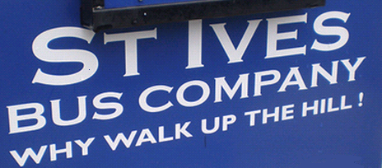
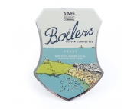
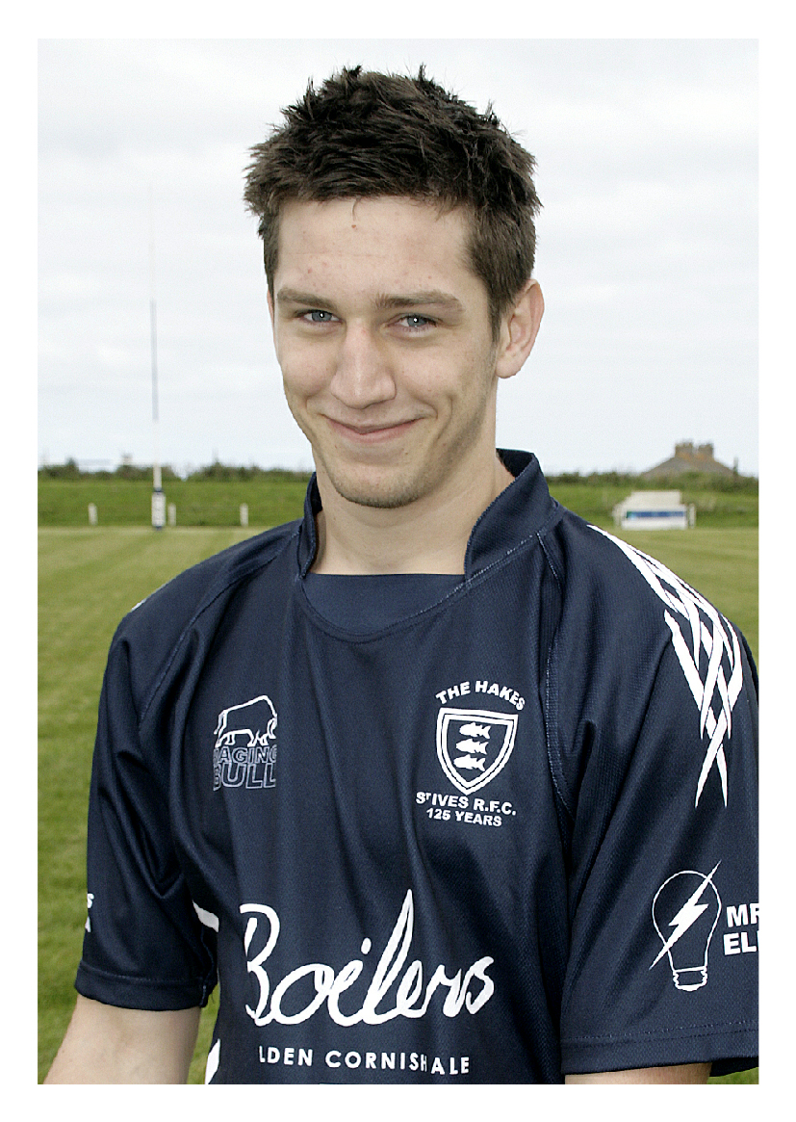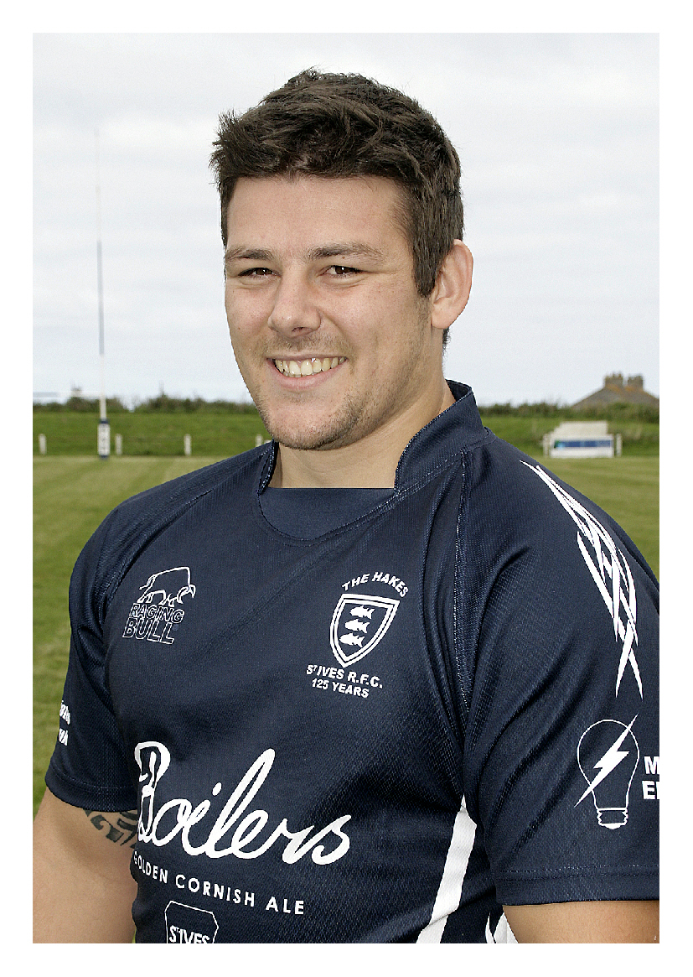
St Ives RFC would like to warmly welcome you to this afternoon’s match and the referee, Mr David May (CRRS). This is the 10th round of league fixtures in the Tribute Cornwall & Devon RFU league. St Ives has produced a series of excellent results this season, remaining unbeaten in the league, playing highly entertaining rugby. The club is thrilled to see increasing support during a time of development both on the pitch and in the clubhouse. The match sponsor is St Ives Bus Company.

Today we welcome Crediton back to The Recreation Ground, our first meeting for 8 seasons. Less than 10 miles north of Exeter, with a population of about 7,000, the club runs senior, colts and junior teams. In 2001 the 1stXV won the SW Counties West league. They finished 6th last season and 4th in 2010-11 in this league. They were champions once during the league’s 25 year history in 1988. Over the years 13 Devon clubs have won this league compared to only 5 Cornish Clubs. Perhaps this might stimulate some discussion as to why this is so. St Ives played against Crediton in The Western Counties (west) league in the 2003-4 season, when St Ives gained promotion through the play-offs against Thornbury. Enjoy the game and we hope to see you in clubhouse after the match.
Alan Thomas

Mark Sherris returns to the 1XV today. Here he makes a clean break against
Pirates Amateurs
during a 44-14 home win

St Ives
Crediton
v
Kyle Moyle
Rob Rowe
Mark Sherris
Tom Nicholas
Ian Veal
Cerion Thomas
Josh Palmer
Scott Perkin
Sean Stevens
Neil Corin
Tom Barber
Rich Humphries
Tony Stevens
Ben Taylor (Capt)
Ben Wheeler
15
14
13
12
11
10
9
8
7
6
5
4
3
2
1
Nathan Ronchetti
Jake Weedon
Mike Pearce
Tom Foan (Capt)
Brad Baker
Tom Ronchetti
Dave Rich
Mark Nott
Dale Palmer
Chris Hooper
John Butt
Richard Gray
Dan Manns
Shane Bayley
Henry Gavin
Replacements
16
17
18
Ben Jenkins
Ellis Cox
Aaron Rowe
Lance Palmer
Sam Rowe
A N Other
Referee: David May (CRRS)
Player Profile (forwards): Ben Taylor
Age: 23 Weight 100kgs (15st 10lbs) Height: 173cms (5’8”)

Ben has represented Cornwall from U.17s to the senior side. He was a part of the cup winning team of 2009-10. Captain of the club, Ben has scored 2 tries this season.
Favourite food: Enchilada; (It’s a tortilla folks).
Player profile (backs): Josh Palmer
Age: 19 Weight: 81kgs (12st 11lbs) Height 183cms (6’0”)
Played his youth rugby at Pz-Newlyn, joined our successful
Colts side and was part of the cup winning team of 2010/11.
Proudest moment: scoring his first senior try in season
2010/11 against Avonmouth.
Five selected for the Cornwall U.20 squad for the 2012-13 season
Congratulations to the following players who have gained selection:
Todd Prisk, Max Bodilly, Kyle Moyle, Tom Chandler and Jacob Ninnes.

I am sure we would all send our good wishes to Simon Hosking who unfortunately broke his leg during the reserve game against Falmouth last weekend. He has received hospital treatment and is now on the road to recovery.
This is your club space. If you have a contribution you think would be of interest
please speak to Alan Thomas or senior coach, Joff Rowe (07837 992 663).
St Ives 50-8 Tiverton
Wessex 0-55 St Ives
Recent results
Plymouth Barbarians 11-12 Crediton
Crediton 5-23 Saltash
Harwood, Lane & Co
Chartered accountants
David Fox FCA
Tel. 01454 772727
www.harwoodlane.co.uk
Pete McNeil
&
Tony Rignall
Roger Corin & C0
Construction Ltd
St Ives MOT
Test Centre
Newly opened
Unit 3a Penbeagle
Cornwall Drinks Group

