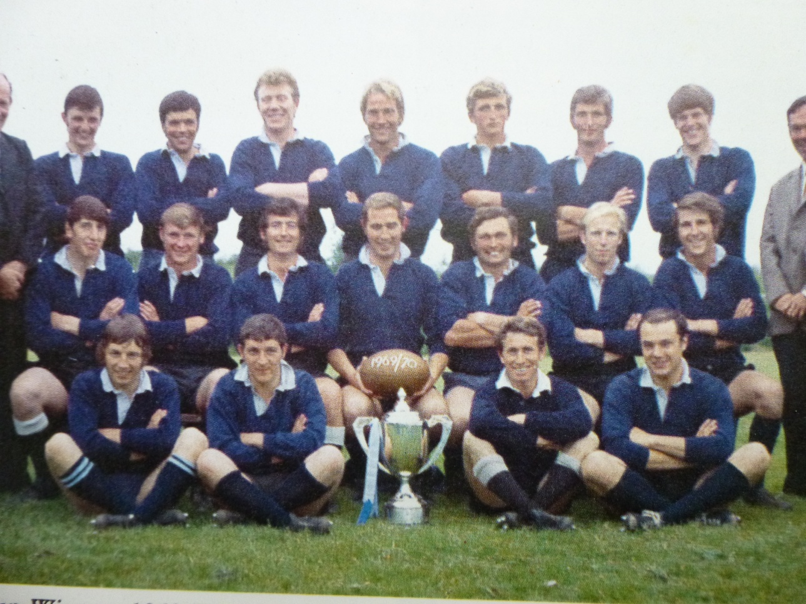

**Successful Exhibition for 125th Anniversary.**

A huge thank you to Lloyd Eddy for gathering some wonderful rugby club memorabilia which was on display at a coffee morning held at The Western Hotel on Friday, 22nd February. This was a foretaste of what the reunion could be, with many past memories shared, graced as it was with the presence of Richard Sharp, Harold Stevens, Jimmy Agnew and Charlie Galbraith.

The most talked about items were the immaculate records of our first team fixtures over the seasons, thanks to the incredible, painstaking work of Brian Burrell and Peter James. Our thoughts and prayers are with Peter and his family as he recovers from illness at RCH Truro. We wish him continued and steady progress.

**A note of thanks and acknowledgement**

The team photos are used with the **kind permission of The St Ives Printing and Publishing Company.**

Two publications worth reading if you can get hold of copies are; **“Alright in the End!”,** by Peter Murrish, produced for the club’s centenary year, and **“The First Hundred Years**”, the story of rugby football in Cornwall, by Tom Salmon, where there is a section on the history of St Ives RFC, largely compiled by Peter James. These were researched for information in this programme.

**1970**

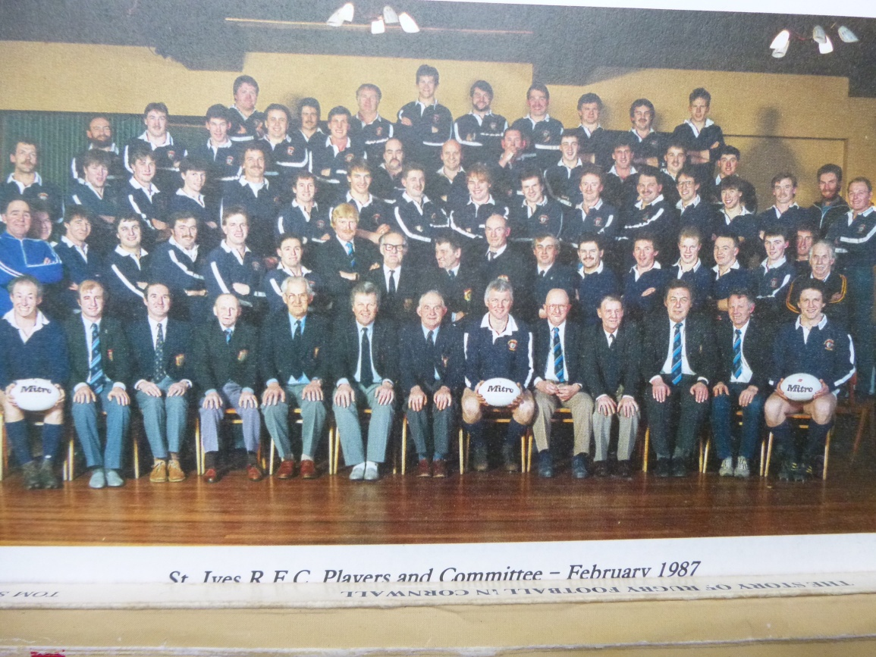

Comparing statistics across the decades:  
Note the fluctuations in matches played and points scored.

|  |  |  |  |  |  |  |
| --- | --- | --- | --- | --- | --- | --- |
| Year | P | W | D | L | F | A |
| 1903-‘04 | 20 | 11 | 3 | 6 | 124 | 77 |
| 1913-‘14 | 29 | 20 | 2 | 7 | 293 | 87 |
| 1928-‘29 | 38 | 23 | 1 | 14 | 505 | 232 |
| 1937-‘38 | 36 | 19 | 6 | 11 | 296 | 202 |
| 1946-‘47 | 33 | 14 | 6 | 13 | 237 | 185 |
| 1955-‘56 | 42 | 25 | 2 | 15 | 380 | 227 |
| 1968-‘69 | 46 | 37 | 1 | 8 | 864 | 241 |
| 1972-‘73 | 46 | 29 | 2 | 9 | 1103 | 434 |
| 1987-‘88 | 44 | 19 | 1 | 14 | 444 | 395 |
| 1997-‘98 | 30 | 7 | 3 | 20 | 422 | 855 |
| 2001-‘02 | 25 | 18 | 1 | 6 | 674 | 426 |
| 2012-‘13 | 20 | 19 | 0 | 1 | 634 | 227 |

**1987**

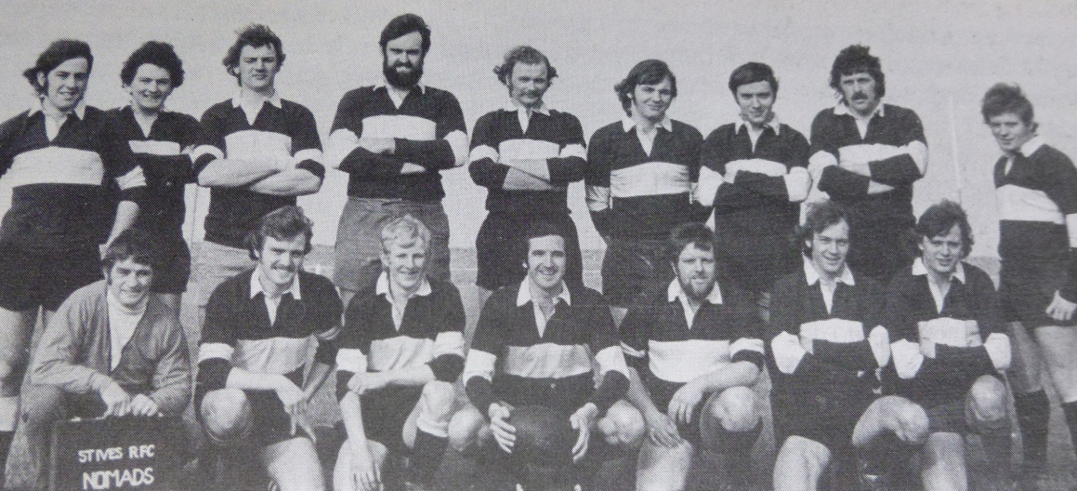

**Nomads1976**

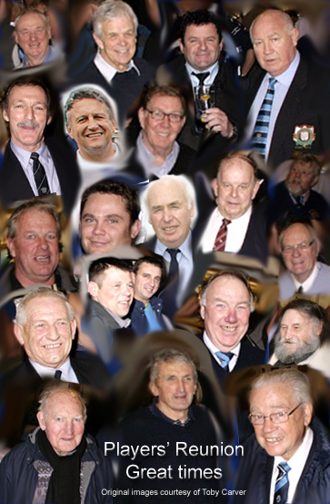

**Previous results against Falmouth with several of the players**

|  |  |  |  |
| --- | --- | --- | --- |
| 5th Jan. 1999 | 23rd Feb. 1991 | 4th Jan. 1975 | 4th Jan 1974 |
| Won (H) Cup | Won (A) | Lost (A) Merit | Lost (A) |
| 24-0 | 33-6 | 0-11 | 7-28 |
| B Gibson | K Nankervis | R & D Corin | J Cocking |
| R Mallet | S Trevorrow | P & C Hendy | A Hart |
| T Bassett | M Smith | J Denholm | D Mungles |
| M Rowe | M Moran | R Trigger | R Knowles |
| C Dunn | I Deacon | B Stevens | M Stevens |
| J Perkin | J Rowe | M Gee | S Moody |
| N Laity | J Atkinson | V Thomas | D Boyns |
|  |  | J Woolcock | T Pascoe |

