League positions 2014-2015
 |  | P | W | D | L | F | A | D | Pts | Adj
2nd | Teignmouth | 17 | 15 | 0 | 2 | 645 | 203 | 442 | 73 | 13
13th | St Ives | 17 | 3 | 1 | 12 | 236 | 829 | -593 | 18 | 4

St Ives v Teignmouth

Saturday 31st January 2015
KO 2:30 p.m.
at
St Ives Recreation Ground

Welcome to the Recreation Ground for the latest round of the Tribute Western Counties West league. Today our visitors are Teignmouth, one of ten teams from Devon that form this league, while Cornwall provides the remaining four.
Teignmouth finished as runners up in this league last year. The club continues to produce excellent form and they currently lie in second place behind Exeter University. They will have to wait until the 21st March when it is likely they will battle it out for top spot. Teignmouth will have the home advantage.
After some promising results before Christmas, St Ives has had many injuries and much unavailability. The latter is sure to affect the former. Showing considerable courage and enthusiasm the young squad have travelled away in difficult circumstances, only to suffer heavy defeats and further injuries. May I recommend that home supporters read the match report for the recent Kingsbridge game? It eloquently describes the effort and pride shown on the field of play.
The match referee for today is James Milliner of CRRS. We ask that you afford him courtesy from the touch line. The club is grateful to all officials for the time they give to our game.
Please join us in the clubhouse for a drink and a chat after the match.
Alan Thomas

Today’s Tribute Western Counties West League fixtures
Devonport Services |  |  | Wellington
St Ives (SW) |  |  | Teignmouth
Exeter University |  |  | Tavistock
Kingsbridge |  |  | Okehampton
Wadebridge Camels |  |  | Sidmouth
Truro |  |  | Penryn
Torquay Athletic |  |  | Tiverton
Next League fixture:
Saturday 7th February: Okehampton v St Ives
Next home league fixture:
Saturday 21st February: St Ives v Torquay Athletic

Tom Chandler makes a typically determined run beyond the Tiverton defence
Courtesy of Barney Carver

St Ives ‘Hakes’ | V | Teignmouth  St Ives Hakes 2015 taken before the home fixture against Tiverton  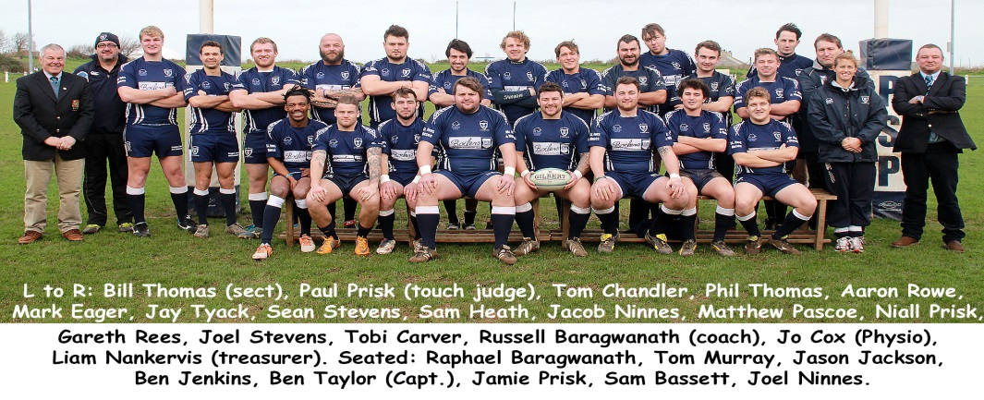  Archive Album  Reunions and the 125th anniversary exhibition have proven to be ideal venues for the airing of many old photos of teams, players and officials from bygone days. Technology now provides another excellent location for such. The club website now has an archive photo album. A few photos have already been added, but there is room for many more. If you have an old photo with at least some detail of the team and season etc., and would like to share it, please send an electronic copy (even if it is a photo of a photo), to me at alanthomas@oneuk.com. I will add it to the album.
Ben Jenkins | 1 | G. Mowson
Ben Wheeler | 2 | P. Parsons
Jay Tyack | 3 | B. Allison
Jamie Prisk | 4 | C. Aldworth (Capt.)
Tom Chandler | 5 | A. Kelly
Tom Murray | 6 | L. Pattison
Graham Corin | 7 | M. Toboggan
Sam Heath | 8 | J. Gray
Jason Jackson | 9 | N. Johns
Jacob Ninnes | 10 | J. Wood
Joe Rouncefield | 11 | D. Force
Tom Nicholas | 12 | M. Saxton
Josh Palmer | 13 | C. Sherlock
Tobi Carver | 14 | REG
Niall Prisk | 15 | S. Fellows
Liam Trudgeon | 16 | P. Scott
Dillon Loake | 17 | J. Bury
Dan Harry | 18 | D. Aldworth
Referee: James Milliner (CRRS)

