League positions 2014-2015
 |  | P | W | D | L | F | A | D | Pts | Adj
12th | Wellington | 10 | 2 | 0 | 8 | 122 | 247 | -125 | 10 | 2
13th | Tavistock | 10 | 1 | 0 | 9 | 134 | 425 | -291 | 6 | 2
14th | St Ives | 10 | 1 | 0 | 9 | 118 | 534 | -416 | 5 | 1

St Ives v Wellington

Saturday 22nd November 2014
KO 2:30 p.m.
at
St Ives Recreation Ground

Today’s Tribute Western Counties West League fixtures
Tavistock |  |  | Sidmouth
Wadebridge Camels |  |  | Truro
Devonport Services |  |  | Torquay Athletic
St Ives (SW) |  |  | Wellington
Kingsbridge |  |  | Tiverton
Exeter University |  |  | Teignmouth
Okehampton |  |  | Penryn
Next league Fixture:  Saturday 6th December  Wadebridge Camels v St Ives | Next home fixture:  Saturday 13th December  St Ives v Sidmouth  Prayers answered as The Hakes get season’s first win
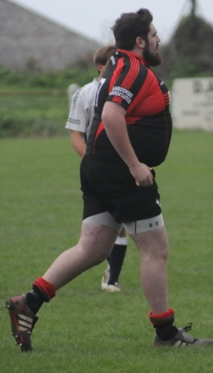
A certain J. Prisk gets his hat trick & MotM
Quick quiz: Who is the St Ives player hidden by one of the Tavistock forwards?
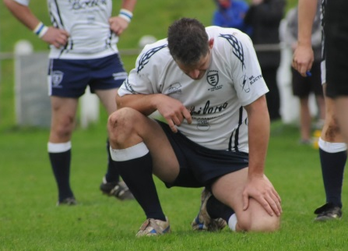
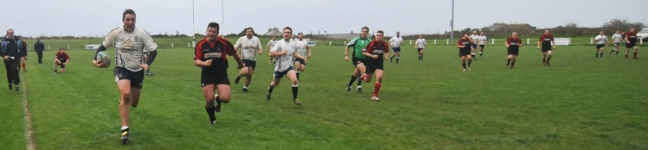


Welcome to Alexandra Road for this latest round in the Tribute Devon & Cornwall Western Counties West League. Many of you will be here for the reunion buffet before the match. Players and officials are very pleased that you have made the effort and hope you enjoy the occasion. No doubt it will stir up anecdotes from the past, where each try was scored from further out, that tackle was an even bigger hit and nostalgia proves once again that times were better ‘in my day’!
Our opponents today are Wellington. Only three players from last year’s 16:14 defeat survive, but there are only three changes from last week’s squad that beat Tavistock. The table on the back page shows that both teams are finding it tough this season, but all their points have come in the last three matches. Wellington has kept large defeats to a minimum, although they have no away wins. St Ives will want to concentrate on their encouraging performance at home to Tavistock, knowing that a win today could take them off the bottom.
Today’s official is Andy Reynolds (CRRS). We trust he also has a successful game and an enjoyable experience here at The Rec.
The club is always indebted to sponsors, whether financial or through the skills they can offer in kind. Perhaps you might consider how you can help your club at this time. Just chat to any of our officials. They tend to wear club ties and blazers.
Alan Thomas

QBE Autumn Internationals
The Big Screen and the TV's in the Clubhouse have been fully serviced and synchronised to give members the opportunity to view the
QBE Autumn Internationals in full HD
The dates and Kick Off times are:-
England v Samoa on Saturday 22nd Nov KO 7:00 pm – dreckly!
England v Australia on Saturday 29th Nov KO 2:30 pm



St Ives ‘Hakes’ | V | Wellington
Liam Trudgeon | 1 | Ollie Price
Ben Taylor (Captain) | 2 | Tom Sargent
Ben Jenkins | 3 | David Swann
Jamie Prisk | 4 | Robert Cooling
Tom Chandler | 5 | Harry Ramsay
Ellis Cox | 6 | Chris Kitto
Joel Ninnes | 7 | Danny Lee
Sam Heath | 8 | Micky Norman
Jason Jackson | 9 | Tim Jenkinson
Jacob Ninnes | 10 | Matt Parsons
Joe Rouncefield | 11 | Nev Pitman
Tom Nicholas | 12 | Will Hancox
Aaron Rowe | 13 | Luke Brown
Raphael Baragwanath | 14 | George Hooper
Niall Prisk | 15 | Liam Symons
Replacements
Dan Harry | 16 | Lee Wadham
Neil Corin | 17 | Jake Smith
Tom Murray | 18 | Leigh Cash
Referee: Andy Reynolds (CRRS)

