Results of most recent league matches against Tavistock
Saturday 1st November 2014: St Ives 39 : 13 Tavistock
St Ives (SW)
W
W
W
W
W
W
W
W
100%
Saturday 28th February 2015: Tavistock 27 : 22 St Ives
Crediton
L
D
D
W
L
D
W
L
22.5%
Tribute Cornwall & Devon RFU League Table
# | Team | Pld | W | D | L | For | Ag | Diff | TB | LB | Pts
1 | Withycombe | 5 | 5 | 0 | 0 | 170 | 70 | 100 | 4 | 0 | 24
2 | Plymouth Argaum | 5 | 4 | 0 | 1 | 147 | 45 | 102 | 3 | 1 | 20
3 | Bude | 5 | 3 | 1 | 1 | 181 | 76 | 105 | 4 | 1 | 19
4 | St Ives (SW) | 5 | 4 | 0 | 1 | 188 | 66 | 122 | 4 | 1 | 16
5 | Falmouth | 5 | 4 | 0 | 1 | 75 | 119 | -44 | 0 | 0 | 16
6 | Pirates Amateurs | 5 | 3 | 0 | 2 | 210 | 92 | 118 | 3 | 1 | 16
7 | Plymstock A Oaks | 5 | 3 | 0 | 2 | 152 | 95 | 57 | 2 | 0 | 14
8 | Paignton | 5 | 2 | 1 | 2 | 134 | 111 | 23 | 2 | 1 | 13
9 | Exeter Saracens | 6 | 2 | 0 | 4 | 124 | 274 | -150 | 2 | 0 | 10
10 | Tavistock | 5 | 2 | 0 | 3 | 65 | 120 | -55 | 1 | 0 | 9
11 | Hayle | 5 | 2 | 0 | 3 | 68 | 169 | -101 | 0 | 0 | 8
12 | Bodmin | 5 | 1 | 0 | 4 | 70 | 119 | -49 | 1 | 1 | 6
13 | Newquay Hornets | 5 | 0 | 0 | 5 | 52 | 156 | -104 | 0 | 3 | 3
14 | Honiton | 6 | 0 | 0 | 6 | 77 | 201 | -124 | 0 | 1 | 1
Next fixtures:  Wednesday 28th October:  St Ives Reserves v Culdrose  Saturday 7th November:  Newquay Hornets v St Ives SW  Bodmin Colts v St Ives Colts  Next home league fixtures:  Saturday 14th November:  St Ives v Plymouth Argaum  St Ives Colts v Launceston Colts  Follow us online:  There is a new website.  We are no longer using Pitchero.  Facebook: StIves Rfc  Website: www.stivesswrfc.co.uk |  |  |  | 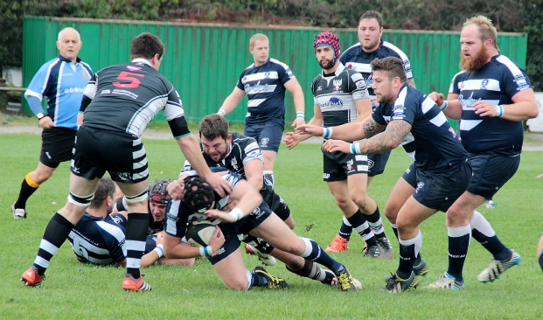
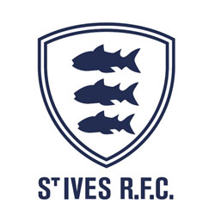

St Ives SW v Tavistock
Saturday 24th October
KO 3:00p.m.
at
St Ives Recreation Ground

Watch the World Cup semi-final
South Africa v New Zealand
in the clubhouse after the match
Ben Wheeler
sets from a Neil Corin offload with
Ben Taylor, Jess Tompsett &
Jamie Prisk in support
Falmouth (away) Sat. 10th October
Courtesy of Tobi Carver

The players and committee of St Ives SW RFC are very happy that you are here to watch the latest match in the Tribute Cornwall & Devon league. Today St Ives faces very worthy opponents in the form of Tavistock. Our visitors encountered a difficult start to the season with fixtures against teams that are currently heading up the league. After today, they will have faced five of the top six. All, bar a pleasing defeat of Bude at home, will have been on the road.
Tavistock, like St Ives, were relegated from Western Counties West at the end of last season, one position above and with one win more. Honours were pretty even in the two games last season, St Ives winning comfortably at home, their first win from nine at the time.
This week’s fixtures will likely leave the top three unchanged, unless there are surprises. St Ives will probably need a bonus point win to stay ahead of Falmouth. So the pressure is on after the disappointment in the last outing. After all the talk and training the performance on the field is what counts. However, St Ives needs points as much as performance. Can the Hakes deliver as a team?
Today’s match official is Al Denham. We wish him well and trust he has your respect from the touch line and on the field of play. The club acknowledges also the effort being made to provide ball boys.

Alan Thomas

St Ives Hakes
Tavistock
v
Tom Nicholas
Lewis Thomas
Laurie Manna
Grant Thirlby
Tom Murray
Paul Thirlby
Sam Carter

Martyn Lawrance
Sam Heath
Cameron Bone
Louis Stevens
Jamie Prisk
Tony Stevens
Ben Taylor (Capt)
Jess Tompsett
15
14
13
12
11
10
9

8
7
6
5
4
3
2
1
Ben Hadfield
Martin Ruskin
Luke Northmore
Ewan Smith
Mark Friend
Doug Lloyd
Gareth Lovell
Andrew Schuttkacker
Callum Thompson
Tom Wheeler
Hallam Bourton
Ash Toll
Ryan Bragg
Carl Parsons
Jude Rötton

Replacements

16
17
18
Sean Stevens
Ben Jenkins
Jacob Ninnes

Jack Jones
Adam Williams

Referee: Al Denham (CRRS)
Today’s mascot is Kaitlyn Borghi, the daughter of the Club Steward, Ludo. Kaitlyn is 9yrs old and in the U9’sthis is the first year of contact rugby. She has only been training
for a couple of weeks, but absolutely loves her rugby.

Reserves match in midweek:
Please make every effort to support the 2nd XV as they play their first home match for a couple of seasons. Here on Wednesday 28th October 7:00p.m.
Results to watch:
Bodmin v Falmouth: Bodmin could do Hakes a big favour in this one. Plymouth Argaum v Pirates Amateurs: Could the Pirates create the biggest upset of the season?
Player Profiles

Full Name – Louis John Stevens
Age - 36 years
Height – 6’2” (1.88m)
Weight – 17st 11lbs (113kg)
Favourite food – Pasty
Favourite drink - Coffee
Favourite film – Crocodile Dundee 2
Honours – Cornwall Senior Squad
Playing position – 2nd Row & Blind side flanker
The ball boys for today are Jake & Max Williams, Talan Pierce, Will Perkin, James & Ellis Marsden, Bailey Rogers and Sam Perkin. The club is grateful for the involvement of the junior section in helping with its smooth running.
Full name – Tom Nicholas
Age – 26
Height – 6’2” (1.88m)
Weight – 14st (89kgs)
Favourite food – Chicken fajitas
Favourite drink - Rekorderlig Cider
Favourite film - Gladiator
Previous clubs - Redruth, Truro, Camborne Honours - Britain & England Fire Service, Cornwall U17 &U20
Playing position - Centre

