ST IVES RFC TICKETING INFORMATION
AUTUMN INTERNATIONALS 2024
GUINNESS SIX NATIONS 2025
Dear Member,
Please find outlined below advice on how to apply for tickets for
- the 2024 Autumn International Matches
- the 2025 Guiness Six Nations Home Matches
You have until 5pm on TUESDAY 23 APRIL 2024 to apply for the 2024 Autumn Nations Series.
You have until Friday 23 August 2024 to apply for the 2025 Guiness Six Nations Series.
YOU CAN ONLY APPLY FOR THESE TICKETS THROUGH PHIL ALLEN, St Ives RFC Ticketing Secretary.
MEN’S SENIOR FIXTURES
Here are the England Men’s Autumn Nations Series 2024 matches, to be played at Twickenham:
- England v New Zealand – Saturday 2 November 2024 – KO 3.10pm
- England v Australia – Saturday 9 November 2024 – KO 3.10pm
- England v South Africa – Saturday 16 November 2024 – KO 5.40pm
- England v Japan – Sunday 24 November 2024 – KO 4.10pm
Here are the England Men’s Guinness Six Nations matches for 2025:
- Ireland v England – Saturday 1 Feb – KO 4.45pm
- England v France – Saturday 8 Feb – KO 4.45pm
- England v Scotland – Saturday 22 Feb – KO 4.45pm
- England v Italy – Sunday 9 Mar – KO 3.00pm
- Wales v England – Saturday 15 Mar – KO 4.45pm

TICKET PRICES FOR THE 2024 AUTUMN NATIONS SERIES
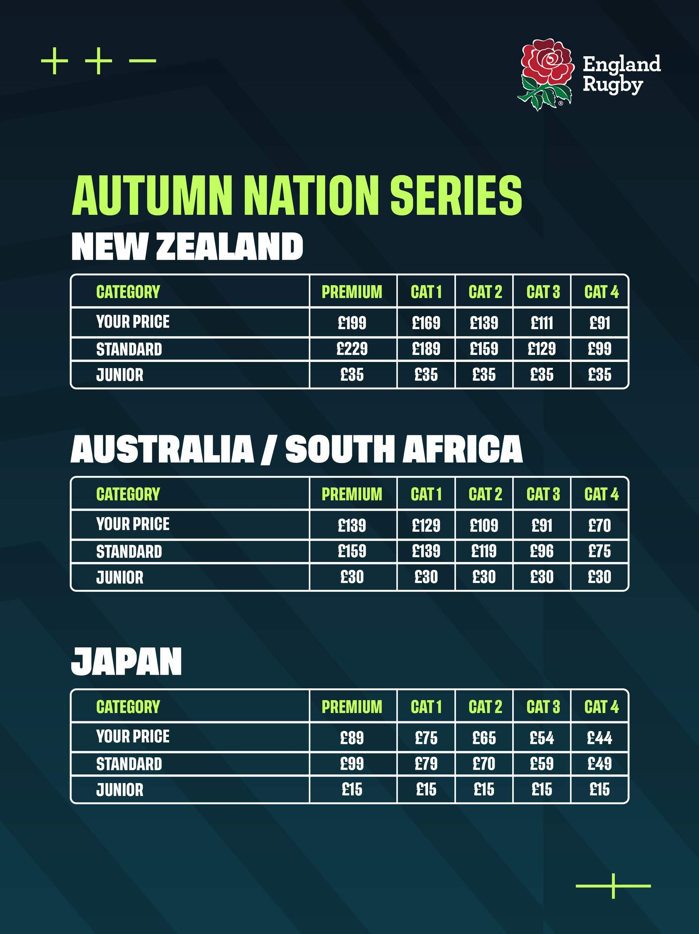

TICKET PRICES FOR THE 2025 GUINESS SIX NATIONS

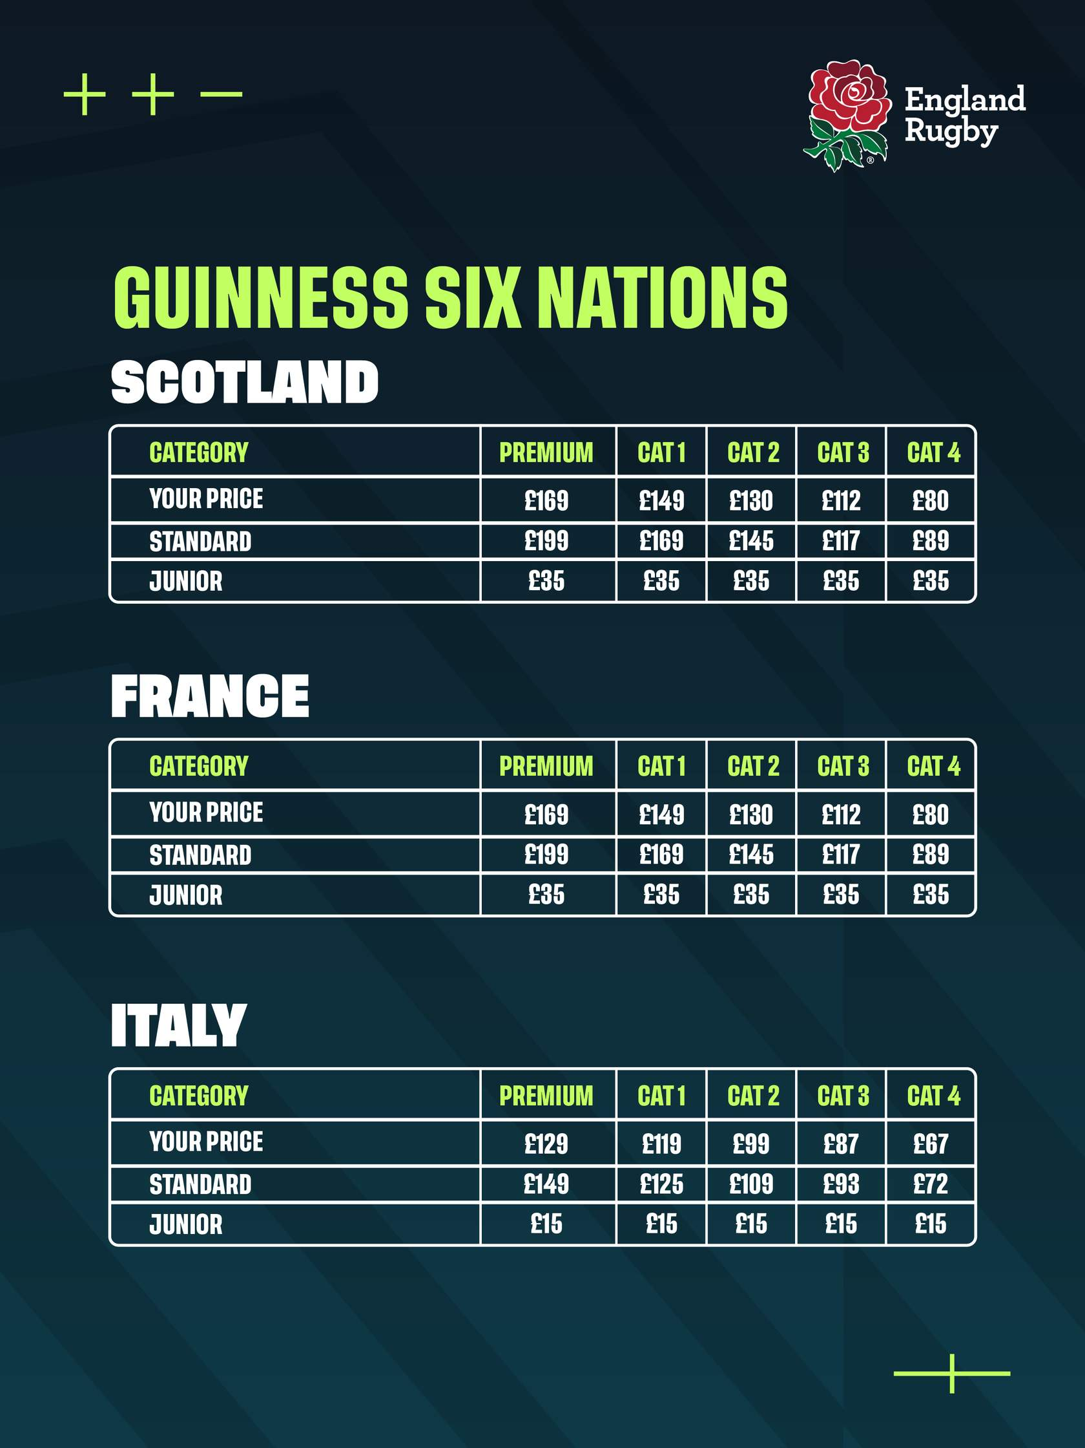

YOU MUST be a fully paid-up member of St Ives RFC if you wish to apply for any of the Senior Men’s tickets. (You can pay for your membership at the same time as you apply for your tickets. Please contact Andrew Perkin for details of the 2024-25 membership fees.)
Please get in touch with Phil Allen, via any of the methods outlined below, if you would like to apply for tickets. You will need to supply ALL the information requested in the application form.
- MOBILE 07512 334 001

- E-mail allen.philip1@sky.com

HOW TO PAY
Please make all payments to the following account using BACS where possible -
BANK BARCLAYS BANK
ACCOUNT NAME ST IVES RUGBY FOOTBALL CLUB TICKET ACCOUNT
(Please use BLOCK CAPITAL LETTERS for the
Account name)
SORT CODE 20-45-45
ACCOUNT NUMBER 40622664
REFERENCE Please use the following reference on your payment
2024 AUTUMN INTERNATIONALS
(AI 2024 (Your Surname) £ (amount you are paying)
e.g. AI2024ALLEN£1234
2025 SIX NATIONS MATCHES
SN2025 (Your Surname) £ (amount you are paying)
e.g. SN2025ALLEN£1234
Please DO NOT pay money into any other St Ives RFC account.

ST IVES RFC TICKET APPLICATION FOR 2024 AUTUMN INTERNATIONALS
NAME
CLUB MEMBERSHIP NUMBER
(Back of card, bottom right)
MATCH  (Indicate your selection with a tick) | - ENGLAND v NEW ZEALAND…………………………………………………  - ENGLAND v AUSTRALIA……………………  - ENGLAND v SOUTH AFRICA……………  - ENGLAND v JAPAN………………………………
NUMBER OF SEATS | - ADULT…………………………………………………  - JUNIOR (U 19) …………………………….
INDIVIDUAL TICKET PRICE  PRICE CATEGORY | - ADULT £……………………………………………  - JUNIOR (U 19) £…………………………  - ………………………………………………………………
TOTAL NUMBER OF TICKETS  TOTAL COST | - ………………………………………………………………  - ………………………………………………………………
* MOBILE TELEPHONE NUMBER  FOR TICKET TRANSFER | - ………………………………………………………………
WOULD YOU LIKE TICKETS IN AN ALCOHOL-FREE ZONE? | - YES…………………………………………………….  - NO……………………………………………………….
DECLARATION
I agree to pay my full membership and ticket costs to St Ives RFC by Monday 02 September 2024. Tickets will not be transferred if this condition is not met.
Signature_____________________________ Date___________________
The earlier you apply for your tickets the greater the choice of location in the stadium and the greater the likelihood of being seated together.
International Ticket Secretary St Ives RFC Phil Allen April 2024

ST IVES RFC TICKET APPLICATION FOR 2025 GUINESS SIX NATIONS
NAME
CLUB MEMBERSHIP NUMBER
(Back of card, bottom right)
MATCH  (Indicate your selection with a tick) | - ENGLAND v FRANCE……………………………….  - ENGLAND v SCOTLAND…………………………  - ENGLAND v ITALY…………………….……………
NUMBER OF SEATS | - ADULT…………………………………………………  - JUNIOR (U 19) …………………………….
INDIVIDUAL TICKET PRICE  PRICE CATEGORY | - ADULT £……………………………………………  - JUNIOR (U 19) £…………………………  - ………………………………………………………………
TOTAL NUMBER OF TICKETS  TOTAL COST | - ………………………………………………………………  - ………………………………………………………………
* MOBILE TELEPHONE NUMBER  FOR TICKET TRANSFER | - ………………………………………………………………
WOULD YOU LIKE TICKETS IN AN ALCOHOL-FREE ZONE? | - YES…………………………………………………….  - NO…………………………………………………….
DECLARATION
I agree to pay my full membership and ticket costs to St Ives RFC by Monday 02 September 2024. Tickets will not be transferred if this condition is not met.
Signature_____________________________ Date___________________
The earlier you apply for your tickets the greater the choice of location in the stadium and the greater the likelihood of being seated together.
International Ticket Secretary St Ives RFC Phil Allen April 2024

