Form Guide (League matches)
2 | St Ives | W | W | W | W | L | W | W | 94.4%
Last week: St Ives 30 – 3 Falmouth
Tribute Cornwall & Devon RFU League Table
# | Team | Pd | W | D | L | F | A | Diff | 4T | LB | Pts
1 | Teignmouth | 21 | 19 | 0 | 2 | 781 | 265 | 516 | 18 | 1 | 95
2 | St Ives (SW) | 21 | 20 | 0 | 1 | 664 | 230 | 434 | 11 | 0 | 89
3 | Tiverton | 20 | 14 | 2 | 4 | 464 | 307 | 157 | 9 | 0 | 69
4 | Saltash | 21 | 14 | 0 | 7 | 576 | 396 | 180 | 9 | 1 | 61
5 | Hayle | 21 | 11 | 2 | 8 | 413 | 399 | 14 | 5 | 2 | 55
6 | Old PMs | 21 | 10 | 0 | 11 | 445 | 514 | -69 | 6 | 1 | 47
7 | Falmouth | 21 | 9 | 0 | 12 | 408 | 526 | -118 | 6 | 3 | 46
8 | Pirates Amateurs | 21 | 8 | 2 | 11 | 369 | 413 | -44 | 5 | 3 | 44
9 | Withycombe | 20 | 8 | 1 | 11 | 389 | 434 | -45 | 5 | 1 | 40
10 | Newquay Hornets | 21 | 7 | 0 | 14 | 449 | 502 | -53 | 7 | 4 | 35
11 | Crediton | 21 | 4 | 3 | 14 | 275 | 421 | -146 | 1 | 4 | 27
12 | Liskeard-Looe | 21 | 4 | 2 | 15 | 276 | 541 | -265 | 3 | 3 | 22
13 | Wessex | 20 | 1 | 0 | 19 | 171 | 732 | -561 | 2 | 1 | 7
Next Fixtures for St Ives teams

Saturday 6th April 2013
Hayle Lions v St Ives Hakes (L)

Saturday 13th April 2013
St Ives Hakes v Liskeard & Looe (L)

St Ives v Imperial Medics

Good Friday 29th March 2013
KO 2:30 p.m.
at
St Ives Recreation Ground
The Imperial Medics are no strangers to St. Ives. The club was formed by the merger of Charing Cross and Westminster Hospitals in 1984, following the advent of leagues in rugby union. In 1997 they were strengthened further when joined with St Mary’s Hospital, whose fortunes were declining, but who had been a source of many internationals.
Imperials Medics have enjoyed considerable success in the oldest competition for such institutions, namely, The United Hospital Cup. All three hospitals were originally formed in the 1800s and have a rich history.
Easter tours were a highlight of seasons in days gone by. St. Thomas’ were always the fixture the day after St. Mary’s. This weekend we have only the Medics to grace our patch. We welcome them and hope for an entertaining encounter, before the medics taste the town’s hospitality.
I am sure all of you are by now aware that St. Ives secured promotion last weekend with another bonus point win, although Falmouth proved to be sturdy opposition. Tiverton, our nearest rivals, are too far behind to catch up. Well done to all the squad, players, coaches and managers.
Congratulations and huge thanks to all who made the reunion such a success. Many very positive comments were exchanged and abiding memories shared. This should encourage the purchase of tickets for the next two events; “Last of the Summer Wine” and the annual club dinner & dance. More details are to be found on the back page.
Finally, we extend a warm welcome to our referee, Mr Jonathan Billing and thank him for giving up his time in order to officiate.
Alan Thomas

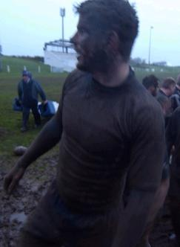
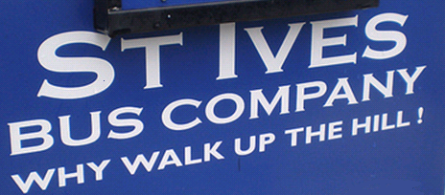
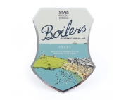
Mud, mud glorious mud. Go on, get stuck in….
Leaving the pitch after nearly being ‘unstuck’ by the foe across the bar. Don’t forget next week’s rematch. Photo:
Mike Cullin Photography
Reminder:

Saturday 13th April 2013 1:00pm
“Last of The Summer Wine”
Members Buffet lunch
See Danny Perkin for details

Friday 3rd May 2013 7:00pm
St Ives RFC 125th Dinner Dance
at Tregenna Castle Hotel
See committee for tickets

SUPPORT YOUR CLUB

Tower of strength, Neil Corin, with an average of one try in each of his 11 appearances, is setting high standards as leading try scorer among the forwards

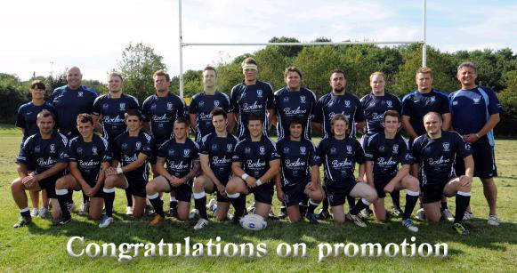
Referee: Mr Jonathan Billing (CRRS)

1. Simon Cole
2. Dan Campioni-Norman
3. Jeeva
4. Conrad Harrison
5. Robbie let greaves
6 Avnish Khilosia
7. Hugh Crawford-Smith
8. TBC
9. Kieran Patel
10. Matthew Harling
11. Vicknesh
12. Marc Macmillan
13. TBC
14. TBC
15. George Hill

As supplied by

Hugh Crawford-Smith
Forwards
Ben | Wheeler
Ben | Taylor
Tyler | Gendall
Ben | Jenkins
Daniel | Harry
Nigel | Laity
Sean | Stevens
Ellis | Cox
Liam | Trudgeon
Barnie | Carver
Tom | Murray
Backs
Max | Bodily
Mark | Sherris
Aaron | Rowe
Josh | Semmens
Jamie | Semmens
Rob | Rowe
Josh | Palmer
Tom | Nicholas
Jamie | Prisk
Henry | Mander
Tobi | Carver
Jacob | Ninnis

ST IVES (Squad)
v
IMPERIAL MEDICS

St Ives MOT
Test Centre
Unit 3a
Penbeagle
Some previous results against Imperial Medics
These proved a little difficult to find for the most recent seasons, but please allow some more ‘125’ indulgence after research at St Ives Archive uncovered several:
1st Apr ‘02 | W 19-17 | Tries: B Warner, L Stevens, A. Keverne
29th Apr ’00 | W 24-17
5th Apr ’99 | L 26-37 | Tries: D Mann (3), M Ward and PG B Peters

The following matches were against St Mary’s Hospital:
1st Apr ‘91 | W 30-0 | Joff Rowe scored 2 tries
Easter ‘87 | D 10-10 | Joff Rowe scored 1 try
23rd Apr ‘74 | W 26-16 | T: M Gee, J, Trevorrow, C Hendy, J Cocking
30th Mar ‘64 | L 0-32 | Centre: S Perkin, Prop: E Symons
23rd Apr ‘62 | L 0-3 | Full back: T Farrell, Flanker: D Stevens
Perhaps the most celebrated international player from St Mary’s Hospital is JPR Williams. Too young to remember? Google him.

Roger Corin & Co
Construction Ltd
Pete McNeil
&
Tony Rignall
Cornwall Drinks Group
Harwood Lane & Co
Chartered accountants
David Cox FCA
Tel. 01454 772727
www.harwoodlane.co.uk

