Form Guide (League matches)
2 | St Ives | W | W | W | W | W | W | W | 100%
1 | Teignmouth | W | W | W | W | W | W | W | 100%
Tribute Cornwall & Devon RFU League Table
# | Team | Pd | W | D | L | F | A | Diff | 4T | LB | Pts
1 | Teignmouth | 17 | 16 | 0 | 1 | 623 | 191 | 432 | 15 | 0 | 79
2 | St Ives (SW) | 17 | 17 | 0 | 0 | 640 | 156 | 484 | 9 | 0 | 75
3 | Tiverton | 17 | 13 | 1 | 3 | 368 | 254 | 114 | 8 | 0 | 62
4 | Saltash | 15 | 10 | 0 | 5 | 419 | 271 | 148 | 7 | 1 | 48
5 | Hayle | 18 | 9 | 2 | 7 | 357 | 350 | 7 | 5 | 2 | 47
6 | Withycombe | 16 | 10 | 0 | 6 | 395 | 301 | 94 | 6 | 0 | 46
7 | Falmouth | 18 | 8 | 1 | 9 | 346 | 451 | -105 | 5 | 1 | 41
8 | OPMs | 16 | 8 | 0 | 8 | 433 | 367 | 66 | 6 | 1 | 39
9 | Pirates Amateurs | 17 | 6 | 1 | 10 | 292 | 367 | -75 | 4 | 3 | 33
10 | Newquay Hornets | 17 | 6 | 0 | 11 | 411 | 407 | 4 | 6 | 2 | 28
11 | Crediton | 17 | 4 | 3 | 10 | 214 | 322 | -108 | 0 | 3 | 25
12 | Liskeard-Looe | 16 | 3 | 1 | 12 | 216 | 450 | -234 | 2 | 2 | 14
13 | Wessex | 16 | 1 | 0 | 15 | 139 | 591 | -452 | 2 | 2 | 8
14 | Plymouth Barbarians | 17 | 1 | 1 | 15 | 92 | 467 | -375 | 0 | 4 | -5
St Ives v Teignmouth

Saturday 12th February 2013
KO 2:30 p.m.
at
St Ives Recreation Ground
We extend a very warm welcome to our opponents, Teignmouth, for the latest round of fixtures in the league. What a prospect today’s fixture brings. It is difficult to avoid using clichés. This is the fixture of the season in the Tribute Cornwall & Devon League. It is the match that stands out on the rugby calendar. Both teams are hot favourites for promotion, but the winners will likely become league champions. Interestingly, recent league opposition was the same for both teams; Saltash and Pirates Amateurs. However, Teignmouth played at home, while St Ives travelled away. So what indicators does the form guide give us?
Last Saturday Teignmouth played Drybrook from Gloucestershire in the South West Final of the RFU Senior Vase, a high point in the club’s history. From the outset of league rugby they were placed in the Cornwall & Devon League, where they have remained, but for one season when there was re-balancing of the leagues in 2000-1. They immediately gained promotion from Devon 1, beating Mounts Bay in the play offs in 2001-2.
As the awful weather continues so does disruption to continuity, with a number of postponements in the league. We are still unsure of the situation regarding Plymouth Barbarians. Patience and encouragement are the virtues required by spectators today. Thanks must go to those who keep our pitch in such good condition in the most difficult of circumstances.
Finally, we warmly welcome Jonathan Billing, today’s match official and ask, as always, that full respect is given from the touch line and the field of play.
Alan Thomas

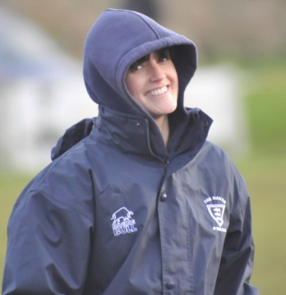
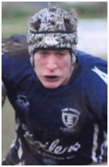
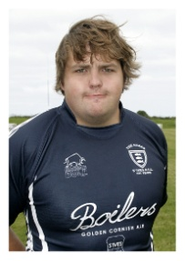
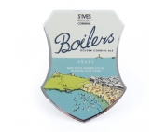
Jo Cox, the team physiotherapist, during the game against OPMs. Given the awful conditions in recent matches, Jo has to be congratulated at smiling for the camera. Thanks for all your hard work Jo. Photo: courtesy of
Mike Cullin.
Next Fixtures for St Ives teams

Today: Saturday 12th February 2013
Saltash Reserves v St Ives Reserves (A)

Saturday 16th February 2013
Tiverton v St Ives 1stXV (A) L
St Ives Reserves v Hayle 2ndXV (H)
St Ives Colts v Newquay Colts (H) L

Saturday 23th January 2013
St Just 2ndXV v St Ives Reserves (A)

Reminder:
Full match reports for 1stXV fixtures can be found on the club website at http://www.pitchero.com/clubs/stivessw

Tower of strength, Neil Corin, with an average of one try in each of his 11 appearances, is setting high standards as leading try scorer among the forwards

Recent league results
Teignmouth 42 - 12 Pirates Amateurs
Teignmouth 27- 8 Saltash
Congratulations to Tyler Gendall and Max Bodilly for their selection in the Exeter Chiefs Academy squad that played Bristol. The club also wish a quick recovery to Todd Prisk who would have been in the squad but is recovering from a damaged hand.
Former St Ives full back Kyle Moyle, who signed for the Cornish Pirates, made his debut recently in the British and Irish cup at Swansea. Congratulations to Kyle and we wish him the very best in his new challenge.
Congratulations to Rob Elloway our senior forwards coach at the club for his recent victories in the Championship for the Cornish Pirates with wins away to Plymouth Albion on Boxing Day and home to Bristol on New Year's Day.

Player profile (backs): Jacob Ninnes 14 App, 12 Tries
Age: 18 Weight: 89kgs (14st) Height 178cms (5’10”)
Honours: Cornwall U.16’s, U17’s, U.18’s and U.20’s. Memorable moments: Winning the colts’ cup final against Launceston at Hayle in 2011; also making full home debut against Wellington last season. Favourite food: Chinese.

Player Profile (forwards): Ben Jenkins17App, 1 Try.
Age: 22 Weight 120kgs (18st 12lbs) Height: 188cms (6’2”)
Position: Loose Head Prop. Previous Clubs: Redruth Colts & Redruth 1st XV. Honours: Cornwall U.16’s, U17’s, U.18’s, U.20’s, Seniors and the South West. Memorable moment: Playing at Franklin’s Gardens
for Redruth Colts Favourite food: Anything.
Pirates Amateurs 11 - 24 St Ives
Saltash 10 - 21 St Ives
ST IVES
TEIGNMOUTH

v

1
2
3
4
5
6
7
8
9
10
11
12
13
14
15

Replacements
16
17
18

Referee: Jonathan Billing (CRRS)
Pete McNeil
&
Tony Rignall
St Ives MOT
Test Centre
Unit 3a
Penbeagle
Cornwall Drinks Group
Harwood Lane & Co
Chartered accountants
David Cox FCA
Tel. 01454 772727
www.harwoodlane.co.uk
Roger Corin & Co
Construction Ltd

