Previous results in Tribute Cornwall & Devon League
23rd March 2013:- St Ives 30 : 3 Falmouth

10th October 2015:- Falmouth 12 : 6 St Ives
Pos | Team | Pd | W | D | L | F |  | A |  | Diff | TB | LB | Pts
1 | Bude | 15 | 12 | 1 | 2 | 542 |  | 180 |  | 362 | 11 | 2 | 63
2 | St Ives (SW) | 15 | 13 | 0 | 2 | 572 |  | 161 |  | 411 | 11 | 2 | 60
3 | Withycombe | 13 | 11 | 0 | 2 | 447 |  | 126 |  | 321 | 8 | 2 | 54
4 | Plymstock Albion Oaks | 15 | 10 | 1 | 4 | 470 |  | 200 |  | 270 | 8 | 1 | 51
5 | Falmouth | 15 | 10 | 1 | 4 | 326 |  | 291 |  | 35 | 3 | 1 | 46
6 | Plymouth Argaum | 14 | 8 | 0 | 6 | 299 |  | 192 |  | 107 | 6 | 3 | 41
7 | Pirates Amateurs | 12 | 8 | 0 | 4 | 342 |  | 219 |  | 123 | 6 | 1 | 39
8 | Paignton | 12 | 7 | 1 | 4 | 217 |  | 209 |  | 8 | 2 | 1 | 34
9 | Bodmin | 15 | 4 | 0 | 11 | 194 |  | 377 |  | -183 | 2 | 2 | 20
10 | Hayle | 15 | 4 | 0 | 11 | 184 |  | 451 |  | -267 | 1 | 2 | 19
11 | Honiton | 15 | 3 | 0 | 12 | 227 |  | 351 |  | -124 | 2 | 3 | 17
12 | Tavistock | 14 | 3 | 0 | 11 | 173 |  | 439 |  | -266 | 2 | 3 | 17
13 | Exeter Saracens | 14 | 3 | 0 | 11 | 249 |  | 647 |  | -398 | 5 | 0 | 17
14 | Newquay Hornets | 14 | 1 | 0 | 13 | 113 |  | 512 |  | -399 | 0 | 3 | 2
Next fixtures  Saturday 30th January  Tavistock v St Ives  Saturday 13th February  St Ives v Newquay Hornets  Follow us online:  There is a new website.  We are no longer using Pitchero.  Facebook: StIves Rfc  Website: www.stivesswrfc.co.uk  Today’s Match Sponsors are: |  |  |  |  | Thanks to you all  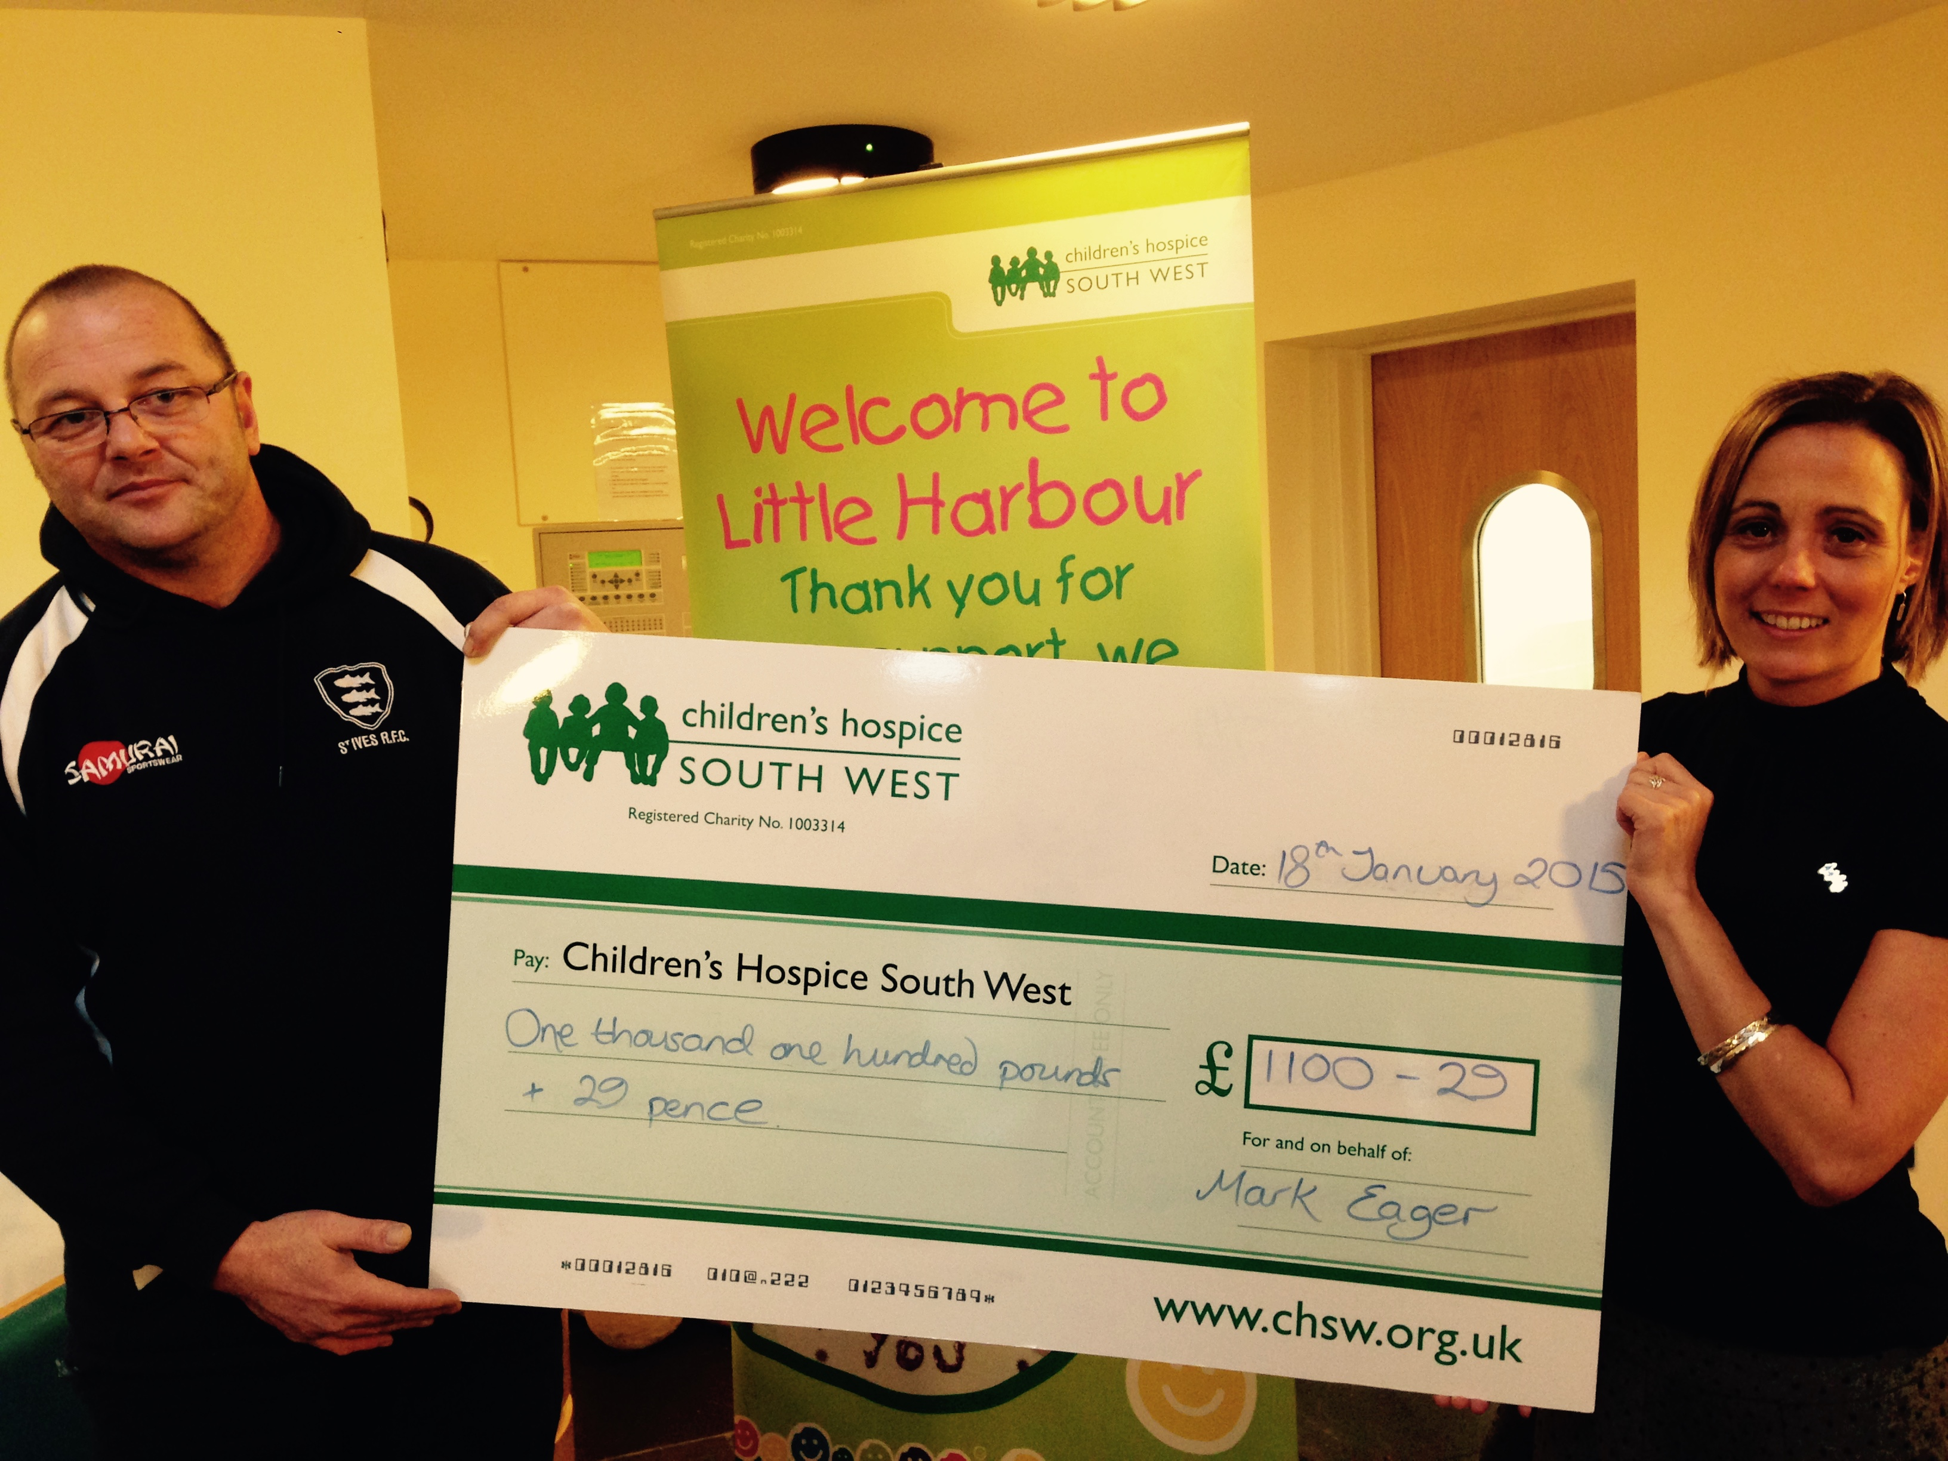Mark Eager proudly presents a cheque for over £1100.00 to Children’s Hospice South West  for Little Harbour
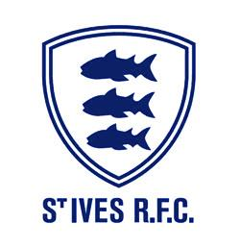

St Ives (SW) RFC extend a warm welcome to you today in this all Cornish encounter between St Ives and Falmouth in week sixteen of the Tribute Cornwall & Devon League. Falmouth last visited us in March 2013 when both sides were in this league. After a two year gap when St Ives played in the league above, the clubs are again facing each other.
It was The Eagles who fought a more street wise battle at Dracaena Avenue back in October to come out winners by 12:6. This was a wakeup call for The Hakes after a run of several high scoring victories. St Ives will be hoping to continue their winning ways this afternoon, but recognise they have a tough task.
Only four players survive from the St Ives team that played back in March 2013; Captain, Ben Taylor, Louis Stevens, Ben Jenkins and Sam Heath. Several players are unavailable today who would be in the squad. Falmouth’s side from last week could name five who played in that game.
Our opponents have held 4th or 5th spot in the league throughout most of the season. Last week they faced Bude at home and were very close to gaining a losing bonus point after a great fight back. This should be an engaging match, with much at stake, especially if St Ives wishes to maintain their promotion prospects.
Our match official for today is Alex Rolfe from Devon RRS. As always, we would ask everyone, on and off the field, to show respect and restraint, even though you think you could do better! Do please join us in the clubhouse after the match for a drink, may be a meal from our excellent kitchen and a chat with friends old and new.
Alan Thomas

St Ives Hakes v Falmouth Eagles
Saturday 23rd January 2016
KO 2:30p.m.
at
St Ives Recreation Ground

Player News & Congratulations
Two key players will be unavailable for the next month. Centre, Greg Loydall and scrum half, Sam Carter are away over the next month training with the Combined Services squad for this year’s competition.
Ben Taylor and Todd Prisk are selected for Cornwall senior squad training in preparation for the county championship in May.
You may be aware that Tony Stevens did not commit to play beyond the New Year. The club is grateful for his involvement this season. This is probably his last appearance. Tony knows the door remains open. In view of this the management have secured a new signing for the front row, Stuart Milner, from Camborne. He is the son of Alan and brother to referee, James.
There is a welcome back from injury to Nathan Allen, who takes over for Peter Mabbott who has work commitments over this weekend.

Full name – Bobby Conroy-Smith
Age – 24 years
Height – 1.73m (5’ 8”)
Weight – 85kgs (13st 6lbs)
Favourite food - Thai
Favourite drink - Guinness
Favourite film – White Chicks
Honours – Royal Navy sharks 7s,
Royal Navy U23's, Worthing College Rugby Academy, Royal Navy Rugby
Playing position – Wing, fullback, outside centre

Player Profiles
Full Name – Jess Tompsett
Age – 26 years
Height – 1.91m (6’3”)
Weight – 125kgs (19st 8lbs)
Favourite food – Steak & chips
Favourite drink – Cider
Favourite film –Old School
Honours – Sussex, South Australia U21s, Cornwall
Playing position – Prop
St Ives Hakes |  |  | v | Falmouth Eagles
Jess Tompsett |  |  | 1 | A Searle
Ben Taylor (Capt) |  |  | 2 | A Geach
Ben Jenkins |  |  | 3 | C Kirk
Jamie Prisk |  |  | 4 | T David
Todd Prisk |  |  | 5 | S Baglow
Sam Heath |  |  | 6 | T Simmons
Cameron Bone |  |  | 7 | C McColl
Martyn Lawrance |  |  | 8 | F Bailey
Jason Jackson |  |  | 9 | J Tyson
 | Paul Thirlby |  | 10 | M Biggins
Nathan Allen |  |  | 11 | T Job
 | Grant Thirlby TTThirlby Thirlby |  | 12 | A Kindjarsky
Tom Nicholas |  |  | 13 | T Spiller
Bobby Connor-Smith |  |  | 14 | M Lea
Lewis Thomas |  |  | 15 | J Symons
Replacements
Tony Stevens |  |  | 16 | O Church
Louis Stevens |  |  | 17 | F Instance
Jamie Hoskin |  |  | 18 | R Baragwanath
Paul Thirlby |  | Coach |  |  | Graham Whitmore
Referee: Alex Rolfe (DRRS)
Cover at scrum half
The club is happy to announce the return of Jason Jackson to the squad. He has agreed to act as cover for Sam Carter during the next month. Jason was a regular in the team last year.

