League positions 2014-2015
 |  | P | W | D | L | F | A | D | Pts | Adj
5th | Tiverton | 13 | 9 | 0 | 4 | 336 | 121 | 215 | 45 | 9
12th | St Ives | 14 | 3 | 1 | 10 | 229 | 725 | -496 | 18 | 4

St Ives v Tiverton

Saturday 10th January 2015
KO 2:30 p.m.
at
St Ives Recreation Ground
Welcome to the first fixture at the home of St Ives (SW) RFC in 2015 and a happy New Year to all. Today we welcome Tiverton rugby club for the 15th round of matches in the Tribute Western Counties West League.
Both sides were relegated from this league in 2011-12. It is Tiverton who have coped better with their return this season, after being third behind St Ives in 2012-13. Tiverton are currently a well-supported club with three senior teams and a colts side. The Quins play in the Devon Senior Merit Div.1, while the Athletics play in Div.3. The debate over the decision to allow only first 15XVs to be in league structures in Cornwall continues. Most of our opponents from Devon and Somerset and few from Cornwall have reserve teams.
Tiverton arrive at this point in the season with a very creditable record. There is a question mark over their Truro result which has been played, but not added to the league table.
St Ives will be doing their level best to continue their home form of late with three wins and a draw since the beginning of November. Both sides had their matches called off last week and should be looking forward to some action.
Andrew Reynolds is our match referee today and we hope he enjoys his afternoon with us. Please respect our officials. Finally, do join us in the club house after the match, or before, for a beverage, hot or cold.

Alan Thomas

Today’s Tribute Western Counties West League fixtures
Devonport Services |  |  | Okehampton
Exeter University |  |  | Kingsbridge
St Ives (SW) |  |  | Tiverton
Truro |  |  | Wellington
Teignmouth |  |  | Penryn
Wadebridge Camels |  |  | Tavistock
Torquay Athletic |  |  | Sidmouth
Next League fixture:
Saturday 17th January: Kingsbridge v St Ives
Next home league fixture:
Saturday 31st January: St Ives v Teignmouth

The scrum is formed during the home win against Penryn
Courtesy of Tobi Carver
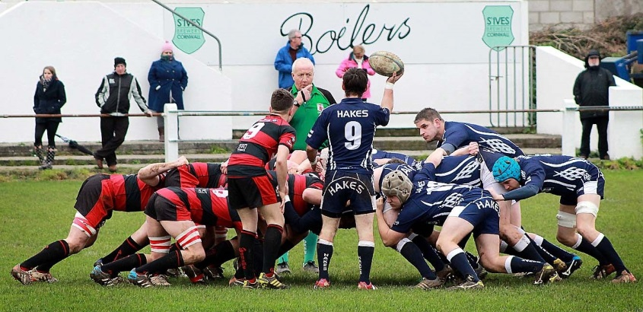



St Ives ‘Hakes’ | V | Tiverton  2011 – 2012 Relegation for both St Ives and Tiverton  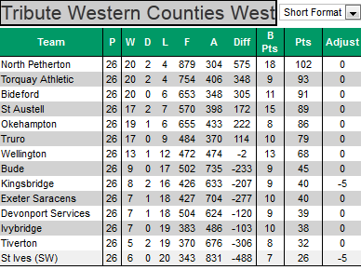  2012 – 2013 St Ives promoted, Tiverton miss out  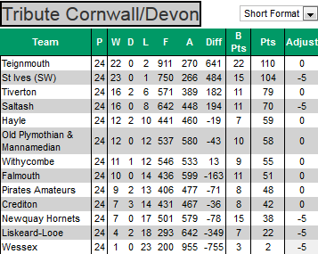  2013 – 2014 Tiverton promoted  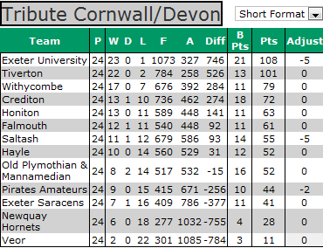  2013 – 2014 St Ives avoid relegation  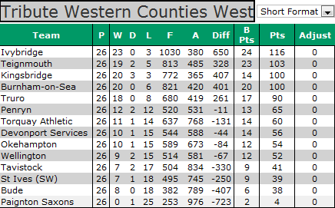
 | 1 | J. Sandow
 | 2 | D. Reed
 | 3 | R. Simmons
 | 4 | T. Skelding
 | 5 | R. Tucker
 | 6 | R. Plume
 | 7 | M. Hague
 | 8 | W. Sprangle (Capt.)
 | 9 | - Howell
 | 10 | M. Down
 | 11 | T. Heard
 | 12 | L. Lewis
 | 13 | S. Smith
 | 14 | E. Howells
 | 15 | A. Willows
Replacements
 | 16 | O. King
 | 17 | J. Kingdon
 | 18 | J. Frankpitt
Referee: Andy Reynolds (CRRS)

